
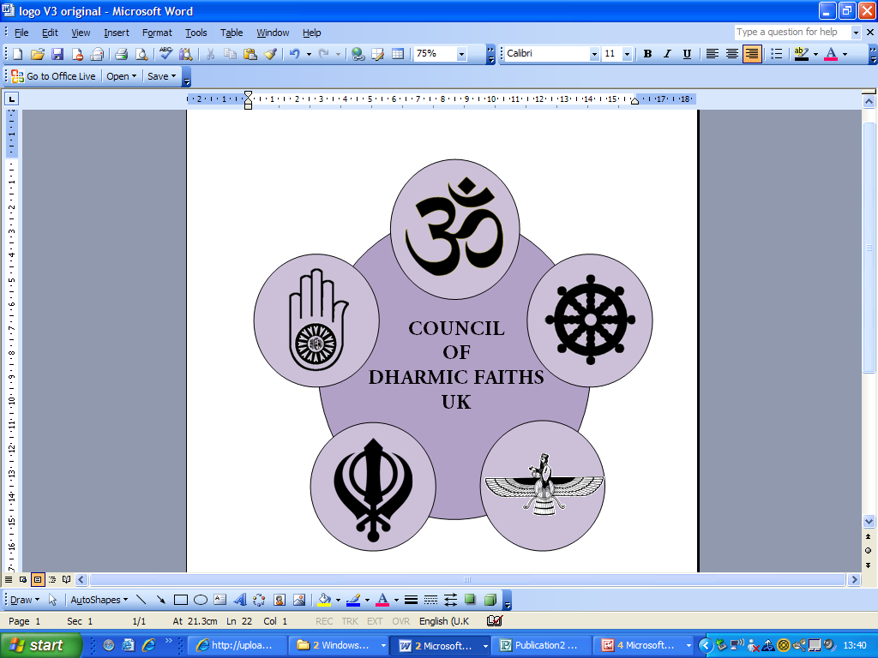
Stephen Hammond MP
supported by
Gareth Thomas MP
John Hemmings MP
cordially request the pleasure of your company
at the launch of
COUNCIL OF DHARMIC FAITHS UK
Organised by the Chair, Dr Natubhai Shah, and the Executive Board
of the Council of Dharmic Faiths UK
On the 16th May 2011 from 16.00 to 18.00 hours
In The Members Dining Room, House of Commons, London, SW1A 0AA
RSVP: Secretary CoDF, 64-68 Colindale Avenue, London, NW9 5DR,
or email: info@dharmicfaiths.co.uk or telephone 0208 200 0828
www.dharmicfaiths.co.uk

